First Cry(Baby Care System)

***Abstract***—*Parenting is not an easy task. Good**parenting requires the parent to quickly respond to the needs of their child. Constant monitoring of the child also becomes a necessity, especially up to an age of 18 months. In this work, a mobile robotic device has been designed and developed. This device can help a parent to keep track of their baby and its surroundings without having to check on the baby every now and then.*

*Advanced Baby Care System (ABCS) has a Master Controller (Arduino Mega 2560), which integrates all the different modules of the robot by receiving the necessary signals from the sensor modules and sending signals to the trigger alarm and the DC motors. The master controller selected for ABCS is the Arduino Mega 2560. It is a microcontroller board based on the ATmega328. This board can be easily interfaced with the CMUCam5 module, used for tracking, as well as other sensors which are being used in the project.*

*ABCS is an intelligent, baby friendly system, which integrates many functions into a single device, automatically alerting the parent when it is necessary and allowing them to carry on with their activities uninterrupted****.***

**Keywords*—*** Mobile Robot, Baby Care,Microcontroller, Pixy module, Arduino.

1. **INTRODUCTION**

Quick response to a child‘s needs and their constant monitoring, up to an age of 18 months, is a prerequisite in parenting. Back in the day, parents relied on hearing the cries of child. This was fairly easy when parents were less busy and homes much smaller. A little negligence on the part of parents can cost a lot, especially since kids are known to run behind mischief [1].

There have been a lot of deaths and accidents reported, in GCC as well as around the world, such as children falling off balconies, playing with guns, putting their hands into live sockets, falling into buckets filled with water and so on. These kinds of tragedies could have been avoided if there was somebody to constantly monitor the activities of the child

This lead us to the development of the ‗Advanced Baby Care System‘, a robotic device suitable for present times, serving as an aid in parenting for single and working parents, who find it difficult to attend to their children and engage in other activities at the same time such as cooking, household chores, office work and so on. However, it is not intended to replace the parent or baby sitter completely. Instead, it supports them.

Currently, most popular baby monitoring devices allow parents to monitor their child through motion and sound. Devices such as walkie talkies and video cameras are used for this purpose. These are stationary devices, helpful in situations where the baby is confined to its crib, when the baby is asleep or in early stages of development. Also, the parent has to constantly look at the baby monitor in order to know what their child is doing. There is no way of knowing if they are in danger, until it‘s too late.

ABCS is a device capable of following children who able to crawl or walk and thus helping parents keep track of them, while being engaged in their tasks. ABCS has been designed as a device which can serve as a helping hand to a parent, following the child and automatically alerting them so that the child does not wander off to unsafe zones around the house.

1. **METHODOLOGY**

The complete project is divided into several phases, according to the different applications. All the applications to be included in ABCS is then arranged according to priority. These were then individually tested to meet the required specifications. As a final step, all the different phases are merged together in the master controller, along with the alarm system.

Following this, the chassis for the project is designed, keeping in mind, the placement of all the components used in the final prototype. Once this is accomplished, the system is made more user-friendly by covering the outside, while allowing room for the sensors alone.

The various features of ABCS:

 An intelligent tracking system which can follow the baby and alert parents when the baby wanders to any unsafe locations in the house, such as balcony or plug sockets [4].

 Alerts parents if baby goes near large electrical appliances or hot objects such as flat iron.

 Diaper change indication.

 Capable of monitoring baby during sleep and alerts parents if the baby wakes up.

 Room temperature and humidity indication, essential for the well-being and development of baby

 ‗Safe Zone‘ indication – alerts parents when baby wanders off far away in places such as parks.

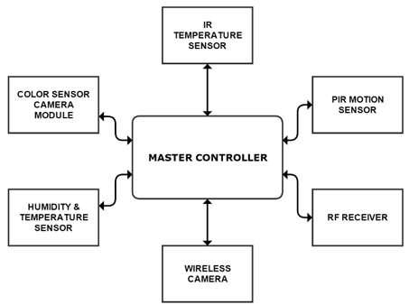

Fig. 1 System Architecture of ABCS

The complete system architecture of ABCS has been depicted in Fig. 1 As seen from the Figure 1, the various sensors such as the temperature sensor, the camera image sensor, humidity sensor and RF module have been integrated to work together in the master controller. An alarm system is included in this work to automatically alert the parents if the child is prone to danger.

The master controller integrates all the different modules of the robot by receiving the necessary signals from the sensor modules and sending signals to the trigger alarm and the DC motors. The master controller selected for ABCS is the Arduino Mega 2560. It is a microcontroller board based on the ATmega328. This board can be easily interfaced with the CMUCam5 module, used for tracking, as well as other sensors which are being used in the project. This board was chosen because of its compatibility with the tracking module, along with the availability of a lot of input and output ports, which is necessary for integration of the various sensor modules.

**III. TRACKING BY COLOR IMAGE SENSOR CHIP PIXY CMU CAM5**

Unlike most monitoring devices which are stationary, ABCS is designed to be a mobile robot capable of faithfully following the child. It can assist in tracking the child and making sure that the child does not wander off to places of potential danger, such as near hot objects, electrical appliances or areas where large amount of water is stored.

Color tracking is achieved by using a highly sophisticated and fast image sensor chip called ‗Pixy‘, interfaced with Arduino Mega2560.

The robot does the task of tracking the subject using color sensing technique. This is accomplished by having the child wear a unique coloured clothing, enabling the robot to follow that particular color. The color worn by the subject can be made known to the robot by simply pressing a button present on the top of it. Pixy has the capability of detecting ‗color codes‘ i.e. up to seven different colors together. This makes for a robust system, ensuring that there is no false detection.

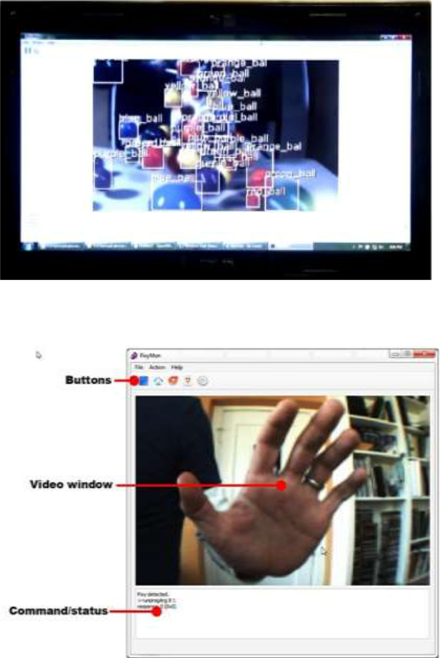

Fig. 2 Pixy detecting, discriminating and tracking objects with different hue simultaneously

Fig. 1 PixyMon window

It was tested that Pixy module is able to detect the coloured object upto 3 meters.

**IV. UNSAFE AREA INDICATION**

Certain places in the house such as balcony, washroom, staircase, etc. are unsafe for the baby to be in. These areas have caused more than 75% of the accidents related to babies that we see today. ABCS can alert the parents if their baby is in the vicinity of such areas.

The Pixy module used for tracking and hence following the baby is used for this application as well. These dangerous areas, as mentioned above, can be marked by colour codes. A colour code is two or more colour tags placed close together. Pixy can detect and decode CCs and present them as special objects [7].

A colour code scheme with 2 tags and 4 different colours can differentiate up to 12 unique objects. CCs with 3, 4 and 5 tags and/or more different colors are possible and can allow for many, many more unique objects. CCs also improve detection accuracy by decreasing false detections. That is, there is a low probability that specific colors will occur both in a specific order and close together.

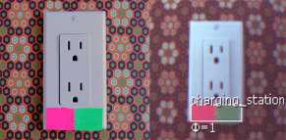

Fig.4 A color code (pink and green) stuck on a socket, to mark a charging station

In the event that these set colour codes come into the field of view of the camera on the pixy module, it will be detected by the Arduino and an alarm is then sounded to indicate that the baby is approaching such an area. The advantage of using colour codes is that any number of places can be marked with these codes. Thus, it is flexible and does not have to be configured for each and every house.

1. **HOT OBJECT DETECTION**

ABCS alerts the parent when a child approaches hot objects. Hot objects are detected by using a non-contact IR temperature sensor which has been implemented in the device. The temperature sensor chosen for this application is the Melexis‘ MLX90614ESF-BAA.

The MLX90614 is an Infra-Red thermometer for non-contact temperature measurements. Both the IR sensitive thermopile detector chip and the signal conditioning ASIC are integrated in the same TO-39 can. Integrated into the MLX90614 are a low noise amplifier, 17-bit ADC and powerful DSP unit thus achieving high accuracy and resolution of the thermometer [8, 9].

The user can configure the digital output to be PWM. As a standard, the 10-bit PWM is configured to continuously transmit the measured temperature in range of -20 to 120 °C, with an output resolution of 0.14 °C.

The sensor has a Field Of View (FOV) of 90°. It detects the average temperature of all the objects in its FOV and sends it to the microcontroller. Thus, the range of this sensor depends on the size and temperature of the object being detected.

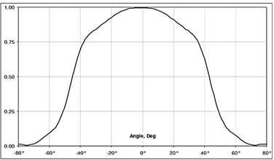

Fig. 5 FOV of MLX 90614 BAA

**VI. DIAPER CHANGE INDICATION**

ABCS has the feature of sensing when the child needs a diaper change, i.e. when the child urinates or defecates. This is achieved using a re-usable ‗H-patch‘. This patch is attached on the outside of the baby‘s diaper so that it is not intrusive or harmful to the baby in any way.

The H-patch design is as follows; it consists of two thin copper conductors and a transmitter, housed in a thin silicon material, which can be placed outside the diaper with copper plates protruded into the inner lining. This design has been chosen to make sure that it does not bother the baby and can be easily removed.

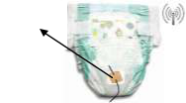

Fig. 6 H-patch on a diaper

Depending on the moisture content of the diaper and the location of the patch the two wires will conduct. When it conducts, a high signal is sent from the transmitter to the receiver present in the robot.

The TX6 is an ASK Hybrid transmitter module. TX6 is designed by the Saw Resonator, with an effective low cost, small size, and simple-to-use for designing

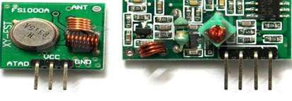

Fig.7. 433 MHz transmitter and receiver modules

**VII.** **‘SAFE ZONE’ MODE**

ABCS will be able to alert parents if their child wanders off away from them, outdoors, in places such as parks or malls. This can ensure that the child will not get lost, due to lack of attention. This feature has been implemented using the RF transmitter-receiver pair, which is being used for diaper change indication. The device can be taken to the parks or malls with parents along with them and be kept with them. Outdoors, the baby doesn‘t need to be tracked and hence these functions can be switched off, thus saving battery. Hence, the application of safe zone has been implemented in the ‗safe mode‘, where only the RF module runs, along with the alarm system. The baby‘s diaper must have the patch attached to it.

When both the transmitter and receiver are out of range i.e. the valid transmission signal on the decoder is low, an alarm will be triggered. The range between the transmitter and receiver can be adjusted using a variable attenuator.

**VIII.** **SLEEP INDICATION**

ABCS does the function of alerting the parent when the child wakes up. This is essential in situations where the child wakes up without crying and wanders off, without knowledge of parents, which can lead to accidents. A sleep mode has thus been implemented on the device. This can be activated by using the switch on the robot, which will switch off the tracking mechanism so that the device can be placed next to the baby‘s bed. A PIR motion sensor has been used to implement this feature in ABCS.

The PIR (Passive Infra-Red) Sensor is a pyroelectric device that detects motion by measuring changes in the infrared levels emitted by surrounding objects. This motion can be detected by checking for a high signal on a single I/O pin.

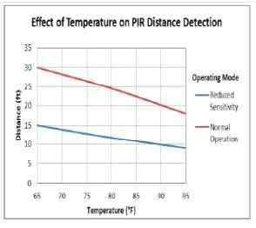

Fig. 8. Distance vs. temperature graph for PIR sensor

**IX. CONCLUSIONS**

This project is designed for the current generation. When both parents are working, it becomes difficult for them to manage their children and accomplish other tasks at the same time. ABCS is a simple and economical solution to assist in parenting. It helps

parents carry out their work without having to constantly check on their child, even when they are asleep. However, this device is not intended to replace a baby sitter completely. Though the device is designed to be child friendly, tampering with the camera or the sensors can render the device useless. Care must be taken that the device does not come in contact with any liquid or extreme heat.

**REFERENCES**

1. N.S. Joshi, R.K. Kamat and P.K Gaikwad, ― Development of

Wireless Monitoring system for Neonatal Interference Care

Unit‖, International Journal of Advanced Computer Research,

Volume 3, Issue 11, 2011.

1. Savita Patil, Manisha R Mhetre, ―IntelligentBaby Monitoring System‖, ITSI Transactions on Electrical and Electronics

Engineering, Vol. 2, Issue 1, 2014.

1. Cynthia L_Altenhofen, ―Baby Monitor System‖, March 28,

2000. Patent No. 6,043,747.

1. M.Geetha, B. Arun kumar, ― Design and Implementation of ARM Based Children Tracking System‖, International

Journal of Advanced Research in Computer Engineering & Technology, Vol. 4, Issue 1, January 2015.

1. J.E. Garcia, R.A. Torres, ― Telehealth mobile system‖, IEEE

Conference publication on Pan American Care Exchange, May 4, 2013.

1. S.Deepika, V.Saravanan, ― An Implementation of Embedded

Multi Parameter Monitoring System for Biomedical Engineering, International Journal of Scientific and Engineering Research, Volume 4, Issue 5, May 2013.

1. Schwaren, Ian, Navigation and control of an Autonomous Vehicle, Master of Science Thesis, Virginia Polytechnic Institute and State University, Blacksburg, Virginia, 2005.
2. Baker Mohammed, Hazem Elgebra, Reem Ashour, and Hani Saleh, ― Portable Wireless Biomedical Temperature

Monitoring System‖, IEEE International Conference

Publication on innovations in Information Technology (IIT), 19 March 2013.

1. Emin Birey Soyer, ―Pyroelectric Infrared Sensor Based Event

Detection, MSc Thesis, July 2009.

1. Prithviraj Shetti, Prasad V, Sakharpe, Amrut Ubare, ― On New Approach in Using 433MHz Radio Module‖,

International Journal of Computer Science and Mobile Computing, Vo. 3, Issue 4, April 2014, pp. 340-345.

